Kalinga University
Faculty of CS & IT

Course- BCAAIML
Subject:- Advance Neural Network & Deep Learning
Subject Code – BCAAIML505
Sem- 5th

UNIT-2

Machine Learning vs. Deep Learning:
In the big world of Artificial Intelligence (AI), Machine Learning (ML) and Deep Learning (DL) are two very powerful areas. They are closely related, but they have key differences. Understanding these differences is super important for anyone wanting to work with data.

What is Machine Learning?
Machine Learning is a part of AI that lets computers learn from data without being directly told what to do. Imagine you want to teach a computer to spot spam emails. Instead of writing rules for every single type of spam, you give it a huge collection of emails that are already marked as "spam" or "not spam." The ML program then learns patterns from this data to figure out new, unread emails are spam or not.
ML programs are trained on data to find connections and patterns. They then use these patterns to make predictions or decisions on new information. It's all about helping systems learn and get better through experience.

Types of Machine Learning:
We usually divide Machine Learning into types based on how the data is used for training:
- Supervised Learning: Think of this like learning with a teacher. You give the computer labeled data, meaning each piece of information comes with the correct answer. The goal is for the computer to learn how to get from the input to the correct output so it can predict answers for new, unlabeled inputs.
  - Example 1 (Email Spam Detection): You give the computer a list of emails where each one is clearly marked "Spam" or "Not Spam." The computer learns what makes an email spam. When a new email arrives, it predicts if it's spam or not.
  - Example 2 (House Price Prediction): You give the computer data about many houses, including their size, location, and their selling price (which is your label/answer). The computer learns how these features affect the price. Then, you give it details about a new house, and it tells you the likely price.
- Unsupervised Learning: Here, there's no "teacher" or correct answers given. The computer works with unlabeled data and tries to find hidden patterns, structures, or groups on its own.
  - Example 1 (Customer Grouping): An online store looks at data about what its customers buy. The customers aren't sorted into groups beforehand. An Unsupervised Learning program can automatically group customers with similar buying habits (like "frequent shoppers" or "discount lovers").
  - Example 2 (News Article Sorting): You have many news articles, but they aren't put into categories. Using Unsupervised Learning, the computer can automatically group articles based on similar topics (like "Sports," "Politics," "Entertainment").
- Reinforcement Learning: (This is an important one to add!) This is about a computer program (called an "agent") learning to make decisions by taking actions in an environment to get the most "rewards." It learns by trying things out and making mistakes, much like how humans learn to ride a bike.
  - Example (AI Playing Games): You teach an AI to play chess or a video game. When the AI makes a good move, it gets a "reward." When it makes a bad move, it gets a "penalty." By playing repeatedly, the AI learns which moves lead to winning.

What is Deep Learning?
Deep Learning is a specialized part of Machine Learning. It uses artificial neural networks (ANNs), which are computer models inspired by how the human brain works. These networks have many layers, letting them learn very complex patterns and connections in data.
Deep learning models need huge amounts of data and a lot of computing power. They are excellent at tasks involving complex data like images, sounds, and text. The word "deep" in Deep Learning comes from the many layers within these neural networks.

Key Deep Learning Types:
Deep Learning has several powerful structures, each good for different types of data and tasks:
- Convolutional Neural Networks (CNNs): Mostly used for image and video processing. CNNs are great at automatically learning different parts of an image, which makes them perfect for things like finding objects or recognizing faces.
  - Example (Face Recognition on Your Phone): The face unlock feature on your smartphone. A CNN model is trained on millions of face pictures, learning tiny details about faces (like eye shape, nose structure). When you pick up your phone, it instantly recognizes your face.
- Recurrent Neural Networks (RNNs): Best for sequential data like time series (data over time), speech, and text. RNNs have a built-in "memory" that allows them to process information in a sequence, making them useful for things like understanding speech and translating languages.
  - Example (Auto-complete Text): When you're typing on your phone, and it suggests the next word (like "How are you?"). RNNs remember the sequence of your previous typing and suggest the most likely next word based on that.
- Long Short-Term Memory (LSTMs): A more advanced type of RNN that solves some problems standard RNNs have. LSTMs are especially good for longer sequences and are widely used in understanding text and speech.
  - Example (Sentiment Analysis): Analyzing social media posts or customer reviews to see if they are positive, negative, or neutral. An LSTM model can understand the order of words and their meaning in a sentence, even if the sentence is very long, to figure out the emotion.
- Generative Adversarial Networks (GANs): These are made of two competing neural networks (a "generator" and a "discriminator"). GANs can create very realistic fake data like images, audio, or text.
  - Example (Generating Fake Faces): You might have seen incredibly real-looking faces online that don't belong to any actual person. GANs are used to create such pictures that look like they came from a real dataset (like real face photos).
- Transformers: A newer and very influential structure, especially in Natural Language Processing (NLP). Transformers are designed to handle long-range connections in data very well and are the foundation for big language models like GPT and BERT.
  - Example (Chatbots and AI Writing Assistants): Large language models like ChatGPT, which can have human-like conversations or write articles, are based on the Transformer structure. They understand the complex relationships between words in sentences and paragraphs.
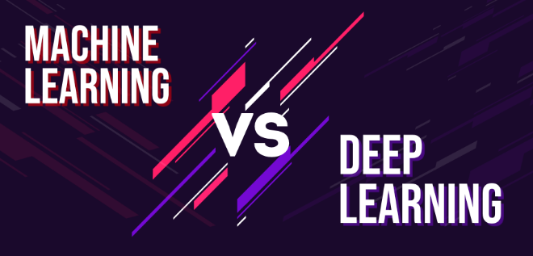

Machine Learning vs. Deep Learning: The Main Differences

Feature | Machine Learning (ML) | Deep Learning (DL)
Relationship | Think of it as the bigger category; DL is inside ML. | It's a specific type (a subset) of Machine Learning.
Data Needed | Works well with smaller to medium amounts of data. | Needs huge amounts of data (millions of data points) to work well.
Feature Engineering | Often needs manual feature engineering (humans tell the computer which features are important). | Automated feature learning. Neural networks automatically find and extract important features from raw data. &lt;br> Example: For ML, you might have to manually tell the computer what cat whiskers or ears look like. For DL, it learns these features on its own.
Computer Power | Generally needs less computer power. Training can often be done on a regular CPU. | Needs a lot of computer power. Training usually requires a powerful GPU (Graphics Processing Unit).
Training Time | Models train relatively faster because of less data and simpler designs. | Training can take a very long time due to huge datasets and complex network designs.
Model Complexity | Uses simpler models like decision trees, linear regression. | Uses complex, many-layered artificial neural networks.
Human Involvement | More human effort in choosing algorithms and picking out features. | Less human effort once the network is designed and training starts (though setting it up can be complex).
Explainability | Results are often easier to understand and explain (e.g., why a certain prediction was made). | Often called a "black box"; it's hard to fully explain how the model made a specific decision.
Problem Type | Good for straightforward or somewhat complex problems like predicting a number or classifying something. | Excellent for very complex problems like recognizing images, understanding speech, or self-driving cars. &lt;br> Example: ML can make a simple chatbot for FAQs. DL can create a more advanced AI assistant like Google Assistant that understands natural speech.
Output Types | Usually numbers, or simple categories (like spam/not spam). | Can produce numbers, text, sound, and other free-form things.

The Future
Both Machine Learning and Deep Learning are fast-growing fields that can change many industries like healthcare, finance, and transport. They help automate complex decisions, find deeper insights from data, and create truly smart systems. As we get more data and computer power becomes cheaper, we can expect even more amazing uses for both ML and DL in the years to come.



The Rise of Deep Learning: How It Changed AI
In the world of Artificial Intelligence (AI), Deep Learning (DL) has become a huge game-changer in recent years. It's not just a fancy new term; it's a technology that has made AI much more powerful and capable than ever before. Let's explore why Deep Learning has become so important and how it's impacting our world.

What Made Deep Learning So Popular?
Deep Learning isn't new, but it's only in the last decade or so that it really took off. Several key things came together to make this happen:
- Lots and Lots of Data (Big Data):
  - Why it's important: Deep Learning models are like hungry students – they need tons of examples to learn effectively. The more data they see, the better they become at spotting patterns and making predictions.
  - The rise: With the internet, social media, smartphones, and sensors everywhere, we started generating massive amounts of data (text, images, videos, audio) like never before. This "Big Data" became the perfect fuel for Deep Learning models.
  - Real Example: Think about how many photos are uploaded to Instagram or Facebook every day. This huge collection of labeled images (e.g., this is a "cat," this is a "car") is what helped image recognition systems become so good.
- Powerful Computers (GPUs):
  - Why it's important: Deep Learning models have many layers and millions (sometimes billions!) of calculations. This needs a lot of raw computing power.
  - The rise: Graphics Processing Units (GPUs), which were originally made for video games, turned out to be perfect for the kind of math Deep Learning needs. They can do many calculations at the same time, making training much faster.
  - Real Example: Training a complex image recognition model might take weeks on a regular computer (CPU), but with a powerful GPU, it can be done in days or even hours. This speed allows researchers to experiment and improve models much faster.
- Better Algorithms and Techniques:
  - Why it's important: Even with data and power, we needed smarter ways to train these deep networks.
  - The rise: Researchers developed new ideas and methods, like better ways to initialize network weights, new "activation functions" (how neurons process information), and methods to prevent models from "overfitting" (becoming too specialized to the training data).
  - Real Example: Techniques like "dropout" and "batch normalization" helped make training deep networks more stable and effective, allowing them to learn from complex data without breaking down.
- Open-Source Tools and Frameworks:
  - Why it's important: Building Deep Learning models from scratch is very hard. Easy-to-use tools make it accessible to more people.
  - The rise: Companies like Google (TensorFlow) and Facebook (PyTorch) released powerful, free, open-source software libraries. These tools made it much easier for developers and researchers to design, build, and train Deep Learning models without having to write all the complex code themselves.
  - Real Example: A student can download TensorFlow or PyTorch and quickly start building their own image classifier using pre-built components, without needing a Ph.D. in computer science.

Where Deep Learning Has Made a Big Impact:
Deep Learning has achieved amazing breakthroughs in many areas that were very difficult for traditional AI.
- Computer Vision (Making Computers "See"):
  - Before DL: Computers struggled to reliably identify objects or faces in images.
  - With DL: CNNs (Convolutional Neural Networks) have revolutionized this field.
  - Real Example 1 (Face Recognition): Your smartphone unlocking just by looking at your face, or Facebook suggesting tags for your friends in photos.
  - Real Example 2 (Self-Driving Cars): Cars can "see" pedestrians, other cars, traffic signs, and lane markings in real-time to drive safely.
  - Real Example 3 (Medical Imaging): Helping doctors spot diseases like cancer or tumors in X-rays or MRI scans more accurately.
- Natural Language Processing (NLP - Making Computers "Understand" Language):
  - Before DL: Computers had a hard time understanding the meaning and context of human language.
  - With DL: RNNs, LSTMs, and especially Transformers have completely changed NLP.
  - Real Example 1 (Voice Assistants): Talking to Siri, Alexa, or Google Assistant, and they understand your commands.
  - Real Example 2 (Machine Translation): Google Translate giving surprisingly accurate translations between languages.
  - Real Example 3 (Chatbots and AI Writing): Chatbots that can answer complex questions, or AI tools that can write emails, articles, or even creative stories (like ChatGPT).
- Speech Recognition (Making Computers "Hear" and "Understand" Speech):
  - Before DL: Speech recognition was often inaccurate and struggled with different accents or noisy environments.
  - With DL: Deep neural networks significantly improved accuracy.
  - Real Example: Dictating messages on your phone, or using voice commands in your car's navigation system.
- Recommendation Systems (Suggesting Things You Might Like):
  - Before DL: Simpler rules were used.
  - With DL: Can understand more complex user preferences and item features.
  - Real Example: Netflix suggesting movies you'll love, Amazon recommending products you might buy, or Spotify suggesting new music. They learn from your past choices and what similar users like.
- Generative AI (Creating New Things):
  - Before DL: AI was mostly about analyzing existing data.
  - With DL: GANs and other generative models can create entirely new, realistic data.
  - Real Example: AI generating realistic human faces that don't exist, creating new art styles, or even composing music.

Representation Learning:-
Representation Learning is a process in machine learning where algorithms extract meaningful patterns from raw data to create representations that are easier to understand and process. These representations can be designed for interpretability, reveal hidden features, or be used for transfer learning. They are valuable across many fundamental machine learning tasks like image classification and retrieval.
Deep neural networks can be considered representation learning models that typically encode information which is projected into a different subspace. These representations are then usually passed on to a linear classifier to, for instance, train a classifier.
Representation learning can be divided into:
- Supervised representation learning: learning representations on task A using annotated data and used to solve task B
- Unsupervised representation learning: learning representations on a task in an unsupervised way (label-free data). These are then used to address downstream tasks and reducing the need for annotated data when learning news tasks. Powerful models like GPT and BERT leverage unsupervised representation learning to tackle language tasks.
More recently, self-supervised learning (SSL) is one of the main drivers behind unsupervised representation learning in fields like computer vision and NLP.

Neural Network Design: Width vs. Depth
When we talk about Deep Learning, we're talking about Neural Networks. These networks are made of many interconnected "neurons" organized into layers. Think of them like layers in a cake. When we design a neural network, two important choices we make are about its width and its depth.

What are Width and Depth in a Neural Network?
Imagine a neural network trying to learn something, like recognizing objects in pictures.
- Network Depth:
  - What it means: This refers to the number of hidden layers in the neural network.
  - Analogy: Think of it as how many "steps" or "levels of processing" the information goes through as it moves from the input to the output. A "deep" network has many hidden layers.
  - Simple Example:
    - Shallow Network (Less Depth): Input Layer -> Hidden Layer 1 -> Output Layer (Only 1 hidden layer)
    - Deep Network (More Depth): Input Layer -> Hidden Layer 1 -> Hidden Layer 2 -> Hidden Layer 3 -> Output Layer (3 hidden layers)
- Network Width:
  - What it means: This refers to the number of neurons (or nodes) in each hidden layer.
  - Analogy: Think of it as how many "workers" or "detectors" are at each "step" or "level" of processing. A "wide" network has many neurons in each layer.
  - Simple Example:
    - Narrow Layer (Less Width): A hidden layer with 10 neurons.
    - Wide Layer (More Width): A hidden layer with 100 neurons.

Trade-offs and Insights: Choosing Between Width and Depth:-
So, should we make our neural networks wide or deep? Both have their pros and cons. It's often a trade-off, meaning you gain something but might lose something else.

1. The Benefits of Depth (More Layers):
- Better at Learning Complex Features:
  - Insight: Deep networks can learn a hierarchy of features. This means early layers learn simple things (like edges or basic shapes), middle layers combine these into more complex things (like eyes or wheels), and later layers combine those into even more abstract concepts (like a "face" or a "car").
  - Real-life Example: In image recognition, a deep CNN can first learn to detect simple lines, then corners, then eyes/noses, and finally combine them to recognize a specific person's face. A shallow network might struggle to build up these complex understandings.
- More Efficient Parameter Usage:
  - Insight: Sometimes, a deep but narrow network can represent very complex functions with fewer total "parameters" (the numbers the network learns) than a very wide but shallow network. This can make them more efficient in some cases.
- Mimics Human Brain More Closely:
  - Insight: Our brains also process information in stages, from simple to complex. Deep networks try to simulate this.

2. The Benefits of Width (More Neurons per Layer):
- Can Learn More Features at Each Level:
  - Insight: A wider layer has more "neurons" working in parallel. Each neuron can learn to detect a different pattern or combination of inputs.
  - Real-life Example: Imagine a wide layer trying to classify different types of fruit. One neuron might become a "banana detector," another a "apple detector," another a "grape detector," all at the same level. A narrow layer might only have enough neurons to distinguish between "round" and "long" fruits.
- Easier to Train in Some Cases (Historically):
  - Insight: For a long time, very deep networks were harder to train because of problems like "vanishing gradients" (where learning signals get too weak through many layers). Wider networks, being shallower, sometimes avoided these issues. (Though new techniques have mostly solved this for deep networks).

3. The Trade-offs / Challenges:
- Computational Cost:
  - Depth: More layers mean more steps, which can slow down training and prediction time.
  - Width: More neurons per layer also mean more calculations, which uses more memory and takes longer.
  - Trade-off: Both wider and deeper networks demand more computing power. Finding the right balance is key.
- Data Requirements:
  - Depth: Very deep networks need a lot of data to learn effectively without "overfitting" (memorizing the training data instead of learning general rules).
  - Width: Wider networks also need sufficient data, but the data requirement scales differently.
  - Insight: A network that's too complex (too deep OR too wide) for the amount of data you have will likely perform poorly on new data.
- Vanishing/Exploding Gradients (More for Depth):
  - Insight: In very deep networks, the "learning signal" (called gradients) can either become tiny (vanishing) or huge (exploding) as it travels back through many layers during training. This makes the network hard to train. (Modern techniques like batch normalization and ReLU activations help fix this).

Current Trends and Insights:
- "Deep is Generally Better": For most complex tasks (like image recognition, natural language processing), deeper networks generally perform better than shallower ones, assuming you have enough data and computational power. The ability to learn hierarchical features is very powerful.
- Balance is Key: While depth is often preferred, simply adding more layers or more neurons endlessly isn't the answer. There's an optimal point.
- Architectural Search: Nowadays, AI researchers often use automated methods to find the best balance of width and depth for a specific problem.

Activation functions in Neural Networks

Activation function decides whether a neuron should be activated by calculating the weighted sum of inputs and adding a bias term. This helps the model make complex decisions and predictions by introducing non-linearities to the output of each neuron.

While building a neural network, one key decision is selecting the Activation Function for both the hidden layer and the output layer. It is a mathematical function applied to the output of a neuron. It introduces non-linearity into the model, allowing the network to learn and represent complex patterns in the data. Without this non-linearity feature a neural network would behave like a linear regression model no matter how many layers it has.

Activation Functions in neural Networks

The Importance of Activation Functions in Neural Networks
You've learned that neural networks are made of layers of "neurons" that process information. But there's a crucial component inside each of these neurons that makes the whole network powerful: the Activation Function.
Think of a neuron as a tiny decision-maker. It takes some inputs, does some calculations, and then passes an output to the next layer. The activation function is what determines if and how strongly that neuron "fires" or sends a signal forward.
Let's understand why non-linearity is a big deal and why we can't build powerful neural networks without activation functions:

1. They Allow Neural Networks to Learn Complex Patterns (Non-Linearity):
- The Problem Without Activation Functions:
  - Imagine a neural network without any activation functions. Every neuron would just perform a simple multiplication and addition (a linear operation).
  - If you stack many linear operations on top of each other, the result is still just one big linear operation.
  - Analogy: Think of it like this: If you add two straight lines, you still get a straight line. If you multiply them, it's still related to a straight line. You can't create curves or complex shapes with just straight lines.
  - Real-life Example Problem: If your network could only learn straight lines, it could never separate complex data. For example, it couldn't tell the difference between "cats" and "dogs" if their features overlap in a curvy, non-linear way (which they almost always do in real life).
- The Solution With Activation Functions:
  - Activation functions (like ReLU, Sigmoid, Tanh, etc.) introduce non-linearity. This means they can bend and twist the data in ways that allow the network to learn much more intricate and complex relationships.
  - Analogy: Now, with activation functions, it's like being able to draw curves, circles, and any complex shape you need. This ability to "bend the data" is what makes deep learning powerful.
  - Real-life Example Solution: With non-linear activation functions, a neural network can learn to identify the subtle, non-linear features that distinguish a "cat" from a "dog," or understand the complex rules of human language.

2. They Decide if a Neuron "Fires" (Thresholding):
- Insight: Many activation functions act like a "switch." If the input to the activation function is above a certain value, the neuron "activates" and sends a strong signal. If it's below that value, it sends a weak or no signal.
- Analogy: Think of a light switch. Below a certain pressure, it stays off. Above that pressure, it clicks on. An activation function can make a neuron "fire" only when its combined inputs reach a certain level of importance.
- Real-life Example: In a medical diagnosis network, a neuron might activate strongly only when it detects enough evidence of a particular disease. If the evidence is weak, it remains mostly inactive.

3. They Help Determine the Output Range:
- Insight: Some activation functions (like Sigmoid or Tanh) "squash" the output of a neuron into a specific range (e.g., between 0 and 1, or -1 and 1). This can be useful, especially for output layers.
- Real-life Example:
  - If you're building a network to predict the probability of something (like the probability of a customer clicking an ad), you need the output to be between 0 and 1. A Sigmoid activation function is perfect for this, as it guarantees the output is in that range.
  - If you're doing a classification task with multiple categories (e.g., classifying an image as "cat," "dog," or "bird"), the Softmax activation function in the final layer ensures that the outputs are probabilities that add up to 1, indicating the likelihood of each category.

RELU – Properties, advantages, and limitations

Rectified Linear Unit (ReLU) is a popular activation functions used in neural networks, especially in deep learning models. It has become the default choice in many architectures due to its simplicity and efficiency. The ReLU function is a piecewise linear function that outputs the input directly if it is positive; otherwise, it outputs zero.
In simpler terms, ReLU allows positive values to pass through unchanged while setting all negative values to zero. This helps the neural network maintain the necessary complexity to learn patterns while avoiding some of the pitfalls associated with other activation functions, like the vanishing gradient problem.
The ReLU function can be described mathematically as follows:
f(x)=max(0,x)f(x)=max(0,x)
Where:
- x is the input to the neuron.
- The function returns x if x is greater than 0.
- If x is less than or equal to 0, the function returns 0.
The formula can also be written as:
f(x)={xif x>00if x≤0f(x)={x0​if x>0if x≤0​

If we plot the graph of ReLU activation function, it will appear like this:
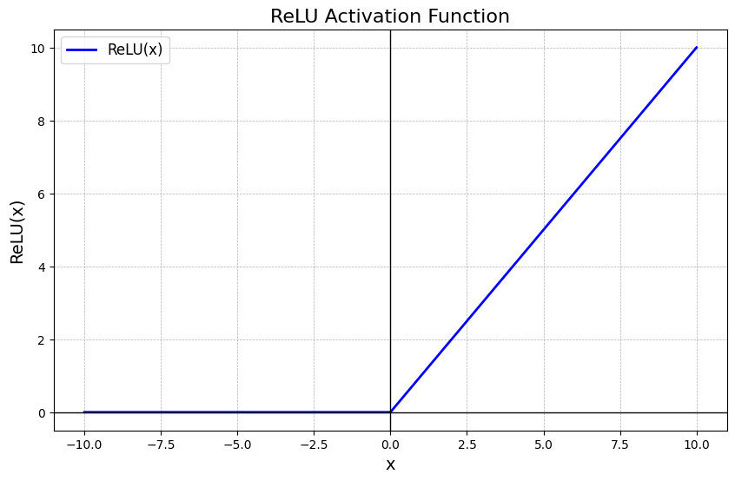

Why is ReLU Popular?
- Simplicity: ReLU is computationally efficient as it involves only a thresholding operation. This simplicity makes it easy to implement and compute, which is important when training deep neural networks with millions of parameters.
- Non-Linearity: Although it seems like a piecewise linear function, ReLU is still a non-linear function. This allows the model to learn more complex data patterns and model intricate relationships between features.
- Sparse Activation: ReLU's ability to output zero for negative inputs introduces sparsity in the network, meaning that only a fraction of neurons activate at any given time. This can lead to more efficient and faster computation.
- Gradient Computation: ReLU offers computational advantages in terms of backpropagation, as its derivative is simple—either 0 (when the input is negative) or 1 (when the input is positive). This helps to avoid the vanishing gradient problem, which is a common issue with sigmoid or tanh activation functions.
- Sparse Activation: ReLU's ability to output zero for negative inputs introduces sparsity in the network, meaning that only a fraction of neurons activate at any given time. This can lead to more efficient and faster computation.
- Gradient Computation: ReLU offers computational advantages in terms of backpropagation, as its derivative is simple—either 0 (when the input is negative) or 1 (when the input is positive). This helps to avoid the vanishing gradient problem, which is a common issue with sigmoid or tanh activation functions.

ReLU vs. Other Activation Functions:-
Activation Function | Formula | Output Range | Advantages | Disadvantages | Use Case
ReLU | f(x)=max⁡(0,x)f(x)=max(0,x) | [0,∞)[0,∞) | - Simple and computationally efficient | - Dying ReLU problem (neurons stop learning) | Hidden layers of deep networks
 |  |  | - Helps mitigate vanishing gradient problem | - Unbounded positive output
 |  |  | - Sparse activation (efficient computation)
Leaky ReLU | f(x)={xx>0αxx≤0f(x)={xαx​x>0x≤0​ | (−∞,∞)(−∞,∞) | - Solves the dying ReLU problem | The slope αα needs to be predefined | Hidden layers, as an alternative to ReLU
Parametric ReLU (PReLU) | Same as Leaky ReLU, but  αα  is learned | (−∞,∞)(−∞,∞) | - Learns the slope for negative values | - Risk of overfitting with too much flexibility | Deep networks where ReLU fails
Sigmoid | f(x)=11+e−xf(x)=1+e−x1​ | (0, 1) | - Useful for binary classification | - Vanishing gradient problem | Output layers for binary classification
 |  |  | - Smooth gradient | - Outputs not zero-centered
Tanh | f(x)=ex−e−xex+e−xf(x)=ex+e−xex−e−x​ | (-1, 1) | - Zero-centered output, better than sigmoid | - Still suffers from vanishing gradients | Hidden layers, when data needs to be zero-centered
Exponential Linear Unit (ELU) | f(x)={xx>0α(ex−1)x≤0f(x)={xα(ex−1)​x>0x≤0​ | (−α,∞)(−α,∞) | - Smooth for negative values, prevents bias shift | - Slower to compute than ReLU | Deep networks for faster convergence
Softmax | f(xi)=exi∑jexjf(xi​)=∑j​exj​exi​​ | (0, 1) (for each class) | - Provides class probabilities in multiclass classification | - Can suffer from vanishing gradients | Output layers for multiclass classifi

Drawbacks of ReLU
While ReLU has many advantages, it also comes with its own set of challenges:
- Dying ReLU Problem: One of the most significant drawbacks of ReLU is the "dying ReLU" problem, where neurons can sometimes become inactive and only output 0. This happens when large negative inputs result in zero gradient, leading to neurons that never activate and cannot learn further.
- Unbounded Output: Unlike other activation functions like sigmoid or tanh, the ReLU activation is unbounded on the positive side, which can sometimes result in exploding gradients when training deep networks.
- Noisy Gradients: The gradient of ReLU can be unstable during training, especially when weights are not properly initialized. In some cases, this can slow down learning or lead to poor performance.
Variants of ReLU
To mitigate some of the problems associated with the ReLU function, several variants have been introduced:
1. Leaky ReLU
Leaky ReLU introduces a small slope for negative values instead of outputting zero, which helps keep neurons from "dying."
f(x)={xif x>0αxif x≤0f(x)={xαx​if x>0if x≤0​
where αα is a small constant (often set to 0.01).
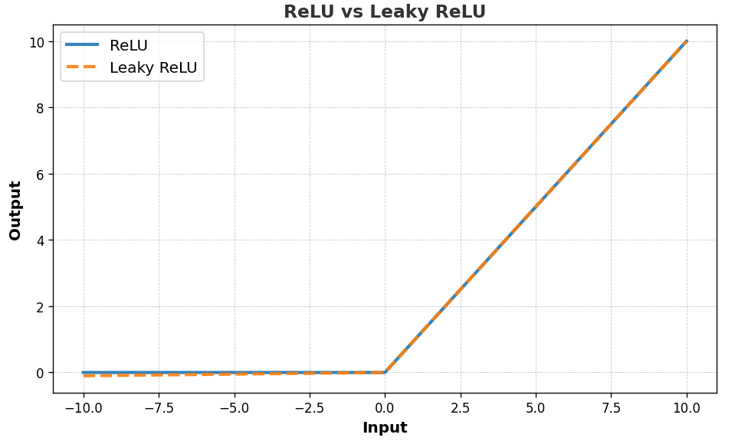
2. Parametric ReLU
Parametric ReLU (PReLU) is an extension of Leaky ReLU, where the slope of the negative part is learned during training. The formula is as follows:
PReLU(x)={xif x≥0α⋅xif x<0PReLU(x)={xα⋅x​if x≥0if x<0​
Where:
- xx is the input.
- αα is the learned parameter that controls the slope for negative inputs. Unlike Leaky ReLU, where αα is a fixed value (e.g., 0.01), PReLU learns the value of α\alphaα during training.
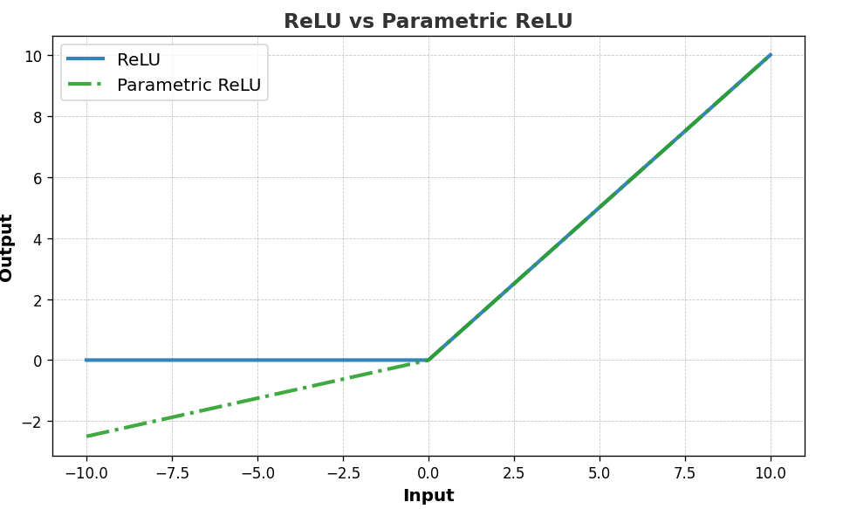
In PReLU, αα can adapt to different training conditions, making it more flexible compared to Leaky ReLU, where the slope is predefined. This allows the model to learn the best negative slope for each neuron during the training process.
3. Exponential Linear Unit (ELU)
Exponential Linear Unit (ELU) adds smoothness by introducing a non-zero slope for negative values, which reduces the bias shift. It’s known for faster convergence in some models.
The formula for Exponential Linear Unit (ELU) is:
ELU(x)={xif x≥0α(exp⁡(x)−1)if x<0ELU(x)={xα(exp(x)−1)​if x≥0if x<0​
Where:
- xx is the input.
- αα is a positive constant that defines the value for negative inputs (often set to 1).
- For x≥0x≥0, the output is simply x (same as ReLU).
- For x<0x<0, the output is an exponential function of x, shifted by 1 and scaled by αα.
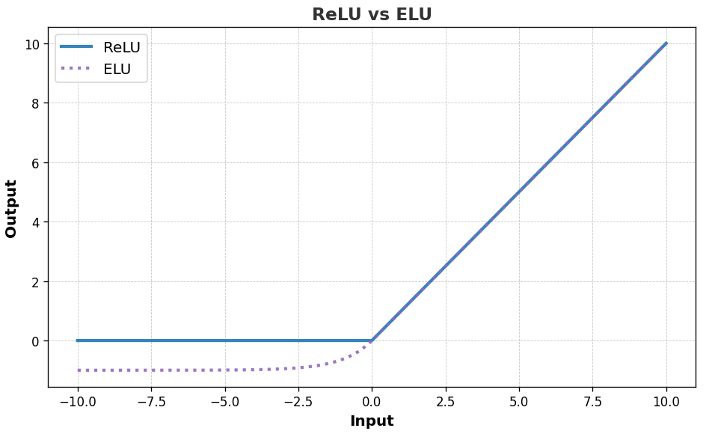
When to Use ReLU?
- Handling Sparse Data: ReLU helps with sparse data by zeroing out negative values, promoting sparsity and reducing overfitting.
- Faster Convergence: ReLU accelerates training by preventing saturation for positive inputs, enhancing gradient flow in deep networks.
But, in cases where your model suffers from the "dying ReLU" problem or unstable gradients, trying alternative functions like Leaky ReLU, PReLU, or ELU could yield better results.
ReLU Activation in PyTorch
The following code defines a simple neural network in PyTorch with two fully connected layers, applying the ReLU activation function between them, and processes a batch of 32 input samples with 784 features, returning an output of shape [32, 10].
import torch
import torch.nn as nn

# Define a simple neural network model with ReLU
class SimpleNeuralNetwork(nn.Module):
def __init__(self):
super(SimpleNeuralNetwork, self).__init__()
self.fc1 = nn.Linear(784, 128) # Fully connected layer 1
self.relu = nn.ReLU() # ReLU activation function
self.fc2 = nn.Linear(128, 10) # Fully connected layer 2 (output)

def forward(self, x):
x = self.fc1(x)
x = self.relu(x) # Applying ReLU activation
x = self.fc2(x)
return x

# Initialize the network
model = SimpleNeuralNetwork()

# Example input tensor (batch_size, input_size)
input_tensor = torch.randn(32, 784)

# Forward pass
output = model(input_tensor)
print(output.shape) # Output: torch.Size([32, 10])
Output:
torch.Size([32, 10])
The ReLU activation function has revolutionized deep learning models, helping networks converge faster and perform better in practice. While it has some limitations, its simplicity, sparsity, and ability to handle the vanishing gradient problem make it a powerful tool for building efficient neural networks. Understanding ReLU’s strengths and limitations, as well as its variants, will help you design better deep learning models tailored to your specific needs.

Understanding LRELU and ERELU: Variants of ReLU
In the world of neural networks, "activation functions" are super important. Think of them as tiny decision-makers within each "neuron" (the building blocks of a neural network). They decide whether a neuron should "fire" (pass on information) or not, and how strongly.
One of the most popular activation functions is ReLU (Rectified Linear Unit). It's very simple:
- If the input is positive, it outputs the input as is.
- If the input is negative, it outputs zero.
While great, ReLU has a small problem called the "dying ReLU" problem. This happens when a neuron always outputs zero for negative inputs, essentially becoming inactive and not learning anymore.
To fix this, smart people came up with variants like LRELU and ERELU!
1. LRELU (Leaky Rectified Linear Unit)
What it is: LRELU is a clever modification of ReLU. Instead of outputting a strict zero for negative inputs, it outputs a small, non-zero slope of the input. It's like giving a "leak" to the negative side.
Simple Explanation: Imagine you have a light switch.
- ReLU: If it's bright, the light is on full. If it's dark, the light is completely off.
- LRELU: If it's bright, the light is on full. If it's dark, the light is still very, very dimly lit, instead of being completely off.
The "Leak" Factor (α or a): This small slope is represented by a small positive constant, usually denoted by α (alpha) or a. Typically, α is a small value like 0.01.
Formula: f(x)={xαx​if x>0if x≤0​
Why it's useful (Applications):
- Solves the "Dying ReLU" problem: Because there's a small gradient for negative inputs, neurons are less likely to become completely inactive, allowing them to continue learning.
- Better for sparse gradients: It helps in situations where gradients (the signals that tell the network how to adjust its weights) might become zero, preventing learning.
Simple Example:
Let's say α=0.01
- If input x=5: f(5)=5 (same as ReLU)
- If input x=−2: f(−2)=0.01×(−2)=−0.02 (instead of 0)
- If input x=0: f(0)=0.01×0=0
Variants of LRELU:
While LRELU itself is a variant of ReLU, sometimes people refer to specific implementations as variants:
- Parametric ReLU (PReLU): This is where the α (the leak factor) is learned by the neural network during training, instead of being a fixed value. This makes the activation function even more adaptable.
  - Application: Often used in deep convolutional neural networks for image recognition tasks, where fine-tuning the activation can lead to better performance.
- Randomized Leaky ReLU (RReLU): Here, the α value is randomly chosen from a given range during training, and then fixed to an average value during testing.
  - Application: Acts as a regularization technique, which helps prevent the neural network from "overfitting" (performing well on training data but poorly on new, unseen data).

2. ERELU (Exponential Rectified Linear Unit) - Often referred to as ELU (Exponential Linear Unit)
What it is: ERELU (or more commonly, ELU) is another powerful variant. For positive inputs, it behaves just like ReLU. But for negative inputs, it uses an exponential function to produce smooth, non-zero negative values.
Simple Explanation: Think of our light switch again:
- ERELU/ELU: If it's bright, the light is on full. If it's dark, the light doesn't just dim linearly; it dims exponentially towards a specific negative value, but never quite reaches it. This makes the transition smoother.
The "Alpha" Parameter (α): Similar to LRELU, ELU also has an α parameter for the negative part. This α value controls the saturation point for negative inputs.
Formula: f(x)={xα(ex−1)​if x>0if x≤0​
where 'e' is Euler's number (approximately 2.71828).
Why it's useful (Applications):
- Smoothness: The exponential part makes the function very smooth for negative inputs. This helps with gradient descent (the process of training neural networks) as it prevents abrupt changes, leading to faster and more stable learning.
- Reduced "dying ReLU" problem: Like LRELU, it avoids the zero output for negative inputs.
- Negative outputs: Allowing negative outputs helps the neural network learn robust representations and pushes the mean activation towards zero. This can help prevent the "vanishing gradient" problem (where gradients become too small, slowing down learning).
Simple Example:
Let's say α=1 (a common choice for ELU)
- If input x=5: f(5)=5 (same as ReLU)
- If input x=−1: f(−1)=1×(e−1−1)≈1×(0.367−1)=−0.632
- If input x=−2: f(−2)=1×(e−2−1)≈1×(0.135−1)=−0.864
- Notice how as x becomes more negative, f(x) approaches −α (in this case, -1) but never quite reaches it.
Variants of ERELU/ELU:
- Scaled ELU (SELU): This is a special case of ELU where α and another scaling parameter (λ) are specifically chosen to make the neural network self-normalizing.
  - Application: When used in deep networks, SELU can automatically push activations towards a mean of zero and unit variance, which can lead to more stable training and better performance in very deep architectures. It's particularly useful for networks that are not using batch normalization.

Unsupervised Training in Deep Learning
Unsupervised learning is a branch of machine learning that deals with unlabeled data. Unlike supervised learning, where the data is labeled with a specific category or outcome, unsupervised learning algorithms are tasked with finding patterns and relationships within the data without any prior knowledge of the data's meaning. Unsupervised machine learning algorithms find hidden patterns and data without any human intervention, i.e., we don't give output to our model. The training model has only input parameter values and discovers the groups or patterns on its own.
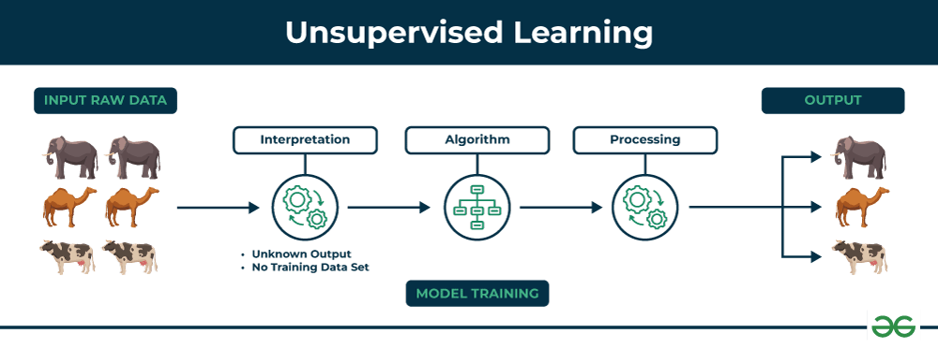
The image shows set of animals: elephants, camels, and cows that represents raw data that the unsupervised learning algorithm will process.
- The "Interpretation" stage signifies that the algorithm doesn't have predefined labels or categories for the data. It needs to figure out how to group or organize the data based on inherent patterns.
- Algorithm represents the core of unsupervised learning process using techniques like clustering, dimensionality reduction, or anomaly detection to identify patterns and structures in the data.
- Processing stage shows the algorithm working on the data.
The output shows the results of the unsupervised learning process. In this case, the algorithm might have grouped the animals into clusters based on their species (elephants, camels, cows).
How does unsupervised learning work?
Unsupervised learning works by analyzing unlabeled data to identify patterns and relationships. The data is not labeled with any predefined categories or outcomes, so the algorithm must find these patterns and relationships on its own. This can be a challenging task, but it can also be very rewarding, as it can reveal insights into the data that would not be apparent from a labeled dataset.
Data-set in Figure A is Mall data that contains information about its clients that subscribe to them. Once subscribed they are provided a membership card and the mall has complete information about the customer and his/her every purchase. Now using this data and unsupervised learning techniques, the mall can easily group clients based on the parameters we are feeding in.
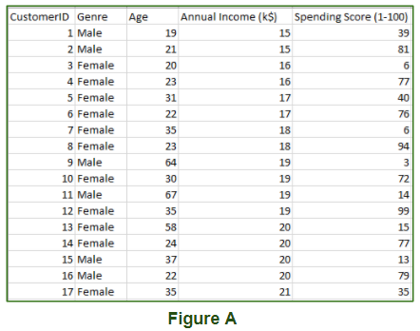
The input to the unsupervised learning models is as follows:
- Unstructured data: May contain noisy(meaningless) data, missing values, or unknown data
- Unlabeled data: Data only contains a value for input parameters, there is no targeted value(output). It is easy to collect as compared to the labeled one in the Supervised approach.

Restricted Boltzmann Machines (RBMs) – Basics
What is a Boltzmann Machine (BM) first?
Imagine a network of interconnected "neurons" (like in our brains or artificial neural networks). In a Boltzmann Machine, every neuron is connected to every other neuron. Some neurons represent things we can see or measure (called visible units), and others represent hidden features or patterns (called hidden units).
The problem with a full Boltzmann Machine is that they are incredibly hard to train because of all those connections.
So, what's "Restricted" about an RBM?
This is where the magic happens! A Restricted Boltzmann Machine (RBM) simplifies the connections significantly:
- No Intra-Layer Connections:
  - Visible units are not connected to other visible units.
  - Hidden units are not connected to other hidden units.
- Only Inter-Layer Connections:
  - Every visible unit is connected to every hidden unit.
  - Every hidden unit is connected to every visible unit.
Think of it like a two-layer sandwich:
- Bottom Layer: Visible Units (V)
- Top Layer: Hidden Units (H)
- Connections: Only between a visible unit and a hidden unit. No connections within the same layer.
Why this restriction?
This restriction makes RBMs much, much easier to train than full Boltzmann Machines. It allows for efficient learning algorithms.

The Two Layers of an RBM:
- Visible Layer (V):
  - These units represent the actual input data you feed into the RBM.
  - Example:
    - If you're training an RBM on images of handwritten digits, each visible unit might represent a pixel in the image (e.g., black or white, or a grayscale value).
    - If you're training it on movie ratings, each visible unit might represent a movie, and its state indicates if a user rated it.
- Hidden Layer (H):
  - These units learn to discover abstract features or patterns within the input data. They don't directly correspond to any input; they learn representations.
  - Example:
    - In an image of a handwritten '8', the hidden units might learn to detect features like "two loops" or "a straight line down the middle."
    - In movie ratings, hidden units might learn "sci-fi enthusiast" or "romantic comedy fan."

How an RBM Works (The "Energy" Concept):
RBMs are part of a family of models called "energy-based models." This means they try to learn a probability distribution over their inputs by assigning an "energy" to each possible configuration of visible and hidden units.
- Lower Energy: Means the configuration (how the visible and hidden units are "on" or "off") is more probable or "makes more sense" to the RBM.
- Higher Energy: Means the configuration is less probable.
The RBM learns to adjust the "weights" (strength of connections) and "biases" (tendency of units to be on) so that configurations similar to your training data have low energy.

Basic Learning Idea (Gibbs Sampling & Contrastive Divergence):
Don't get too bogged down in the math for now, but here's the intuition:
- "Positive Phase":
  - You feed a training example (e.g., an image) into the visible layer.
  - The visible units activate, and this activation "propagates" to the hidden units. The hidden units "turn on" based on what they detect.
  - This represents a "good" or desired state of the network where visible data and learned features are consistent.
- "Negative Phase":
  - Now, you take the activations from the hidden units (from the previous step) and propagate them back to the visible units. This reconstructs an image.
  - Then, you propagate this reconstructed visible state back to the hidden units.
  - This is like the RBM "imagining" or "dreaming" what the data looks like based on its current understanding.
- Learning:
  - The RBM adjusts its weights and biases to increase the probability of the "positive phase" configuration (what you actually fed it).
  - It also adjusts its weights and biases to decrease the probability of the "negative phase" configuration (its "dreamed" or reconstructed version, if it's not accurate).
  - This continuous process helps the RBM learn to reconstruct the input data accurately and discover meaningful hidden features.
This learning process is typically done using an algorithm called Contrastive Divergence (CD), which is an approximation of a more complex method called Gibbs sampling.

Key Applications of RBMs:
- Dimensionality Reduction:
  - Since RBMs learn to represent input data in a compressed form in the hidden layer, they can reduce the number of features needed to describe data, while retaining important information.
  - Example: Reducing a high-resolution image to a smaller set of features without losing its essence.
- Feature Learning:
  - The hidden units learn powerful, abstract features from the raw input data. These learned features can then be used in other machine learning models (e.g., as input to a classifier).
  - Example: An RBM trained on faces might learn features like "nose," "eyes," "mouth," which can then be used by a facial recognition system.
- Collaborative Filtering / Recommender Systems:
  - This is a famous application! RBMs can learn user preferences and recommend items.
  - Example: The Netflix Prize competition saw significant use of RBMs to predict movie ratings. If you rate movies, the RBM can learn your taste and suggest other movies you might like.
- Generative Models:
  - Because RBMs learn to model the probability distribution of the data, they can generate new data that looks similar to the training data.
  - Example: An RBM trained on images of faces could generate new, synthetic faces that look realistic.
- Deep Belief Networks (DBNs):
  - RBMs are often stacked on top of each other to form Deep Belief Networks (DBNs).
  - In a DBN, each layer of RBM learns increasingly complex and abstract representations of the data, leading to very powerful deep learning models.
  - Example: A DBN can be used for deep feature learning for complex tasks like speech recognition or advanced image classification.

RBMs – Architecture and Energy-Based Modeling
We already know that RBMs are like a special type of neural network with two layers: Visible and Hidden. Now, let's look at how they're structured and this idea of "energy."
1. RBM Architecture – The Two-Layer Sandwich
Imagine an RBM as a simple, two-layer neural network with a very specific rule for how its "neurons" (called units in RBMs) connect.
- Layer 1: The Visible Layer (V)
  - What it is: This is where you feed in your raw data. Think of each unit in this layer as representing a single piece of information from your input.
  - Units: Each unit in this layer is a "visible unit."
  - Example:
    - If you're training an RBM to learn handwritten digits (like 0-9), and your images are 28x28 pixels, then you'd have 28×28=784 visible units. Each unit corresponds to one pixel's intensity (e.g., a value between 0 and 255 for grayscale, or just 0 or 1 for black/white).
    - If you're using it for movie recommendations, each visible unit could represent a movie, and its state might be a user's rating for that movie (e.g., 1-5 stars, or just "rated" / "not rated").
- Layer 2: The Hidden Layer (H)
  - What it is: This layer is where the RBM learns to discover abstract features or patterns in your data. You don't directly see these patterns; the RBM "learns" them internally.
  - Units: Each unit in this layer is a "hidden unit."
  - Example:
    - For handwritten digits, a hidden unit might activate (turn "on") if it detects a "loop" shape, or a "vertical line," regardless of where exactly it appears in the input image.
    - For movie recommendations, a hidden unit might represent a genre preference like "sci-fi fan" or "comedy lover."
- The "Restricted" Connections:
  - No Intra-Layer Connections: This is the key restriction!
    - Visible units are not connected to other visible units.
    - Hidden units are not connected to other hidden units.
    - Think of it: there are no direct lines between units within the same layer.
  - Full Inter-Layer Connections:
    - Every visible unit is connected to every single hidden unit.
    - And every hidden unit is connected to every single visible unit.
    - Imagine a dense mesh of lines only between the two layers, but never within a layer.
Why this architecture? This specific setup allows the RBM to have a special property: when you fix the state of the visible units (by feeding it data), the hidden units become conditionally independent of each other. The same is true if you fix the hidden units and look at the visible units. This simplifies the math and makes the RBM trainable!

2. Energy-Based Modeling – The "Happiness" of the Network
This is a core concept behind RBMs (and Boltzmann Machines in general). Instead of directly calculating probabilities, RBMs define an "energy function" for every possible configuration of visible and hidden units.
- Think of it like this:
  - Imagine the RBM is a physical system, like a set of magnets.
  - Some arrangements of these magnets are very stable and "comfortable" – they have low energy.
  - Other arrangements are unstable and "uncomfortable" – they have high energy.
- In an RBM:
  - A low energy configuration means that the visible units and hidden units are in a state that the RBM considers highly probable or "makes sense" based on what it has learned. It's like the RBM is "happy" with this arrangement.
  - A high energy configuration means the state is less probable or "doesn't make much sense" to the RBM. The RBM is "unhappy" with this arrangement.
The Energy Function (The Mathy Bit - Keep it Simple!):
For an RBM, the energy E(v,h) of a given configuration of visible units v and hidden units h is defined by:
E(v,h)=−∑i​ai​vi​−∑j​bj​hj​−∑i,j​vi​hj​wij​
Let's break down what these terms mean simply:
- vi​: The state (e.g., 0 or 1, or a real value) of the i-th visible unit.
- hj​: The state of the j-th hidden unit.
- ai​: The bias of the i-th visible unit. This is like a "preference" for that visible unit to be on, regardless of the hidden units.
- bj​: The bias of the j-th hidden unit. This is a "preference" for that hidden unit to be on.
- wij​: The weight (strength) of the connection between visible unit i and hidden unit j. This determines how much one influences the other.
Interpretation:
- The first two terms (∑ai​vi​ and ∑bj​hj​) are about how "happy" the RBM is with individual units being on (their biases). If a unit has a positive bias and is on, it reduces the energy (makes it more favorable).
- The third term (∑vi​hj​wij​) is about how "happy" the RBM is with pairs of connected units being on together, considering their connection strength (weights).
  - If wij​ is a large positive value, and both vi​ and hj​ are on, it drastically reduces the energy (very favorable).
  - If wij​ is a large negative value, and both vi​ and hj​ are on, it drastically increases the energy (very unfavorable).
The Goal of Training:
During training, the RBM adjusts its ai​ (visible biases), bj​ (hidden biases), and wij​ (weights) so that:
- Real data has low energy: Configurations that match your training examples (the data you feed it) should have very low energy. The RBM "wants" to see these configurations.
- "Bad" or unlikely data has high energy: Configurations that are not like your training data should have high energy. The RBM "doesn't want" to see these.
By minimizing the energy for the correct data, the RBM learns to represent the underlying patterns and probabilities of your dataset. This energy function is then used to define the probability of a given configuration, using a formula that relates lower energy to higher probability.

Introduction to Autoencoders
Imagine you have a big, complicated piece of information, like a detailed drawing. An Autoencoder is a special type of neural network that tries to learn a compressed, efficient representation of that information, and then reconstruct it back to its original form as accurately as possible.
The Core Idea: Learning to Copy Yourself
The most intuitive way to understand an Autoencoder is that it's a network trained to copy its input to its output. It sounds simple, but there's a trick! It must pass the information through a bottleneck or a "bottleneck" layer that forces it to learn a compressed representation.
Think of it like this:
- You have a complex book.
- You need to summarize it in a very short paragraph (the compressed representation).
- Then, you try to rewrite the original book based only on that short summary.
The better you can reconstruct the original book from your summary, the better your summary captures the important information. An Autoencoder works on the same principle!

Types of Autoencoders –
The Two Main Parts of an Autoencoder:
An Autoencoder is essentially made up of two connected parts:
- Encoder:
  - Job: Takes the input data and transforms it into a smaller, more compressed representation. This compressed form is often called the "bottleneck," "latent space," or "code."
  - Analogy: This is like the part of your brain that reads the whole book and then creates that short, insightful summary.
  - Architecture: It's usually a neural network (often with multiple layers) that reduces the number of neurons from the input layer down to the bottleneck layer.
- Decoder:
  - Job: Takes the compressed representation (the "code" from the Encoder) and tries to reconstruct the original input data from it.
  - Analogy: This is the part of your brain that takes your short summary and tries to expand it back into the full, original book.
  - Architecture: It's another neural network that expands the number of neurons from the bottleneck layer back up to the size of the original input layer.
Visualizing it:
Input Data → Encoder → Compressed Code (Bottleneck) → Decoder → Reconstructed Output
The goal is for the Reconstructed Output to be as close as possible to the original Input Data.

How Autoencoders Learn (Training):
- Input: You give the Autoencoder an input, say an image of a handwritten digit "5".
- Encoding: The Encoder processes this image and compresses it into a smaller numerical representation (e.g., a list of 10 numbers). This is the "code" or "bottleneck."
- Decoding: The Decoder takes this code and tries to generate an image that looks like a "5" based only on that code.
- Comparison (Loss Function): The Autoencoder then compares its reconstructed image with the original image. It calculates the "error" or "loss" – how different they are.
  - Example: If the original pixel was black (value 1) but the reconstructed pixel was white (value 0), that's an error.
- Adjustment (Backpropagation): Based on this error, the Autoencoder adjusts its internal "weights" and "biases" (the parameters it learned) in both the Encoder and Decoder. It does this using a technique called backpropagation, trying to reduce the error next time.
- Repeat: This process is repeated thousands or millions of times with many different input examples. Over time, the Autoencoder gets better and better at compressing the data and then reconstructing it accurately.
The Magic: Because the Autoencoder has to compress the data in the middle layer, it's forced to learn the most important, underlying features or patterns in the data to be able to reconstruct it. It can't just memorize the input; it has to understand its essence.

Why are Autoencoders Useful? (Applications):
- Dimensionality Reduction:
  - What it means: Reducing the number of features or dimensions needed to represent data, while keeping most of the important information.
  - How Autoencoders do it: The "code" generated by the encoder is a lower-dimensional representation of the input. Since the decoder can reconstruct the original from this code, it means the code effectively captures the essential information.
  - Example: Taking a very high-resolution image and representing it with far fewer numbers without losing too much visual quality. Useful for speeding up other algorithms or visualizing high-dimensional data.
- Feature Learning (or Representation Learning):
  - What it means: Automatically discovering good features from raw data, rather than having a human manually design them.
  - How Autoencoders do it: The "code" in the bottleneck layer is the learned feature representation. These features are often much more meaningful and robust than raw input features.
  - Example: Training an Autoencoder on a dataset of images, and then using the learned "code" from the encoder as input to a separate image classification model. The classifier will likely perform better because it's getting higher-level, more meaningful features.
- Denoising Data (Denoising Autoencoders):
  - What it means: Cleaning up noisy data.
  - How Autoencoders do it: You intentionally feed the Autoencoder a noisy version of your input, but you train it to reconstruct the clean (original) version. This forces the Autoencoder to learn to remove noise.
  - Example: Taking a blurry photo, and having the Autoencoder output a sharper, cleaner version.
- Anomaly Detection:
  - What it means: Finding unusual or abnormal data points.
  - How Autoencoders do it: Train the Autoencoder on "normal" data. When you then feed it an "anomaly," it will struggle to reconstruct it accurately because it has never seen such a pattern before. A large reconstruction error indicates an anomaly.
  - Example: Detecting fraudulent credit card transactions. If a transaction pattern is very different from what the Autoencoder has learned as "normal" (non-fraudulent) transactions, its reconstruction error will be high, signaling potential fraud.
- Generative Models (Variational Autoencoders - VAES):
  - What it means: Creating new, realistic data that wasn't in the original training set.
  - How Autoencoders do it: While basic Autoencoders don't directly generate, a special type called Variational Autoencoder (VAE) modifies the bottleneck layer to learn a probability distribution. You can then sample from this distribution to generate new data.
  - Example: Generating new, realistic-looking faces that don't belong to any real person.

Deep Learning Applications in Real-World Scenarios
In the field of Artificial Intelligence (AI), deep learning stands out as a revolutionary technology for far-reaching applications. Deep learning, based on neurons driven by the human brain, has revolutionized a variety of fields, from health to finance to finance. Its ability to process large amounts of information and gain meaningful insights has led to unprecedented progress.
Imagine teaching a computer to recognize a cat.
- Old way (Traditional Machine Learning): You'd tell the computer, "A cat has pointy ears, whiskers, and usually four legs." You manually give it a list of features.
- New way (Deep Learning): You just show the computer millions of pictures of cats and non-cats. The "deep" part comes from having many layers of artificial "neurons" in the network. These layers automatically learn the features that define a cat (like edges, textures, shapes, and eventually, the whole cat face) all by themselves, without you explicitly telling them.
Deep Learning is essentially about letting computers learn complex patterns from huge amounts of data, especially when that data is unstructured (like images, audio, or text).

Real-World Deep Learning Applications:
1. Image Recognition and Computer Vision
- What it does: Allows computers to "see" and "understand" images and videos. This includes identifying objects, faces, activities, and even emotions.
- How Deep Learning helps: Deep neural networks (especially Convolutional Neural Networks, CNNs) are excellent at picking out visual patterns from pixels.
- Simple Examples:
  - Facial Recognition: Unlocking your phone with your face, or tagging friends in photos on social media.
  - Object Detection: Self-driving cars identifying pedestrians, other cars, traffic lights, and road signs.
  - Medical Imaging: Helping doctors detect diseases like cancer from X-rays or MRI scans by spotting tiny anomalies.
  - Image Search: When you search for "red shoes" online, the system can understand what "red" and "shoes" look like.
2. Natural Language Processing (NLP) and Speech Recognition
- What it does: Enables computers to understand, interpret, and generate human language, both written and spoken.
- How Deep Learning helps: Recurrent Neural Networks (RNNs) and Transformers are great at processing sequences of data like words in a sentence or sounds in speech.
- Simple Examples:
  - Voice Assistants: Siri, Google Assistant, Alexa understanding your commands and speaking back to you. "Hey Google, what's the weather?"
  - Machine Translation: Google Translate instantly converting text or speech from one language to another (e.g., English to Spanish).
  - Sentiment Analysis: Companies analyzing customer reviews or social media posts to understand if people are happy or upset about a product/service.
  - Spam Detection: Your email provider identifying and filtering out unwanted spam messages.
  - Autocorrect/Predictive Text: Your phone suggesting the next word you might type or correcting your spelling mistakes.
3. Recommender Systems
- What it does: Suggests products, movies, music, or news articles that you might like, based on your past behavior and similar users.
- How Deep Learning helps: Can learn complex relationships between users and items, predicting preferences more accurately than traditional methods.
- Simple Examples:
  - Netflix/YouTube: Recommending movies or videos you'd enjoy based on what you've watched before.
  - Amazon/E-commerce: Suggesting products you might want to buy ("Customers who bought this also bought...").
  - Spotify: Creating personalized playlists or suggesting new artists based on your music taste.
4. Healthcare and Medicine
- What it does: Revolutionizing diagnostics, drug discovery, and personalized treatment.
- How Deep Learning helps: Can process vast amounts of medical data (images, patient records, genetic information) to find patterns invisible to humans.
- Simple Examples:
  - Disease Diagnosis: AI systems analyzing medical scans (like mammograms for breast cancer) to help doctors identify potential issues earlier and more accurately.
  - Drug Discovery: Speeding up the process of finding new drugs by predicting how molecules will interact.
  - Personalized Medicine: Suggesting the best treatment plan for an individual patient based on their unique genetic makeup and health data.
5. Financial Services
- What it does: Improves fraud detection, risk assessment, and trading strategies.
- How Deep Learning helps: Excellent at spotting subtle, non-obvious patterns in large financial datasets.
- Simple Examples:
  - Fraud Detection: Your bank flagging a suspicious credit card transaction that doesn't fit your usual spending patterns.
  - Algorithmic Trading: AI systems analyzing market data in real-time to make rapid buying and selling decisions.
  - Credit Scoring: Assessing a person's creditworthiness based on a wider range of data points than traditional methods.
6. Gaming and Robotics
- What it does: Enables more intelligent game AI, realistic simulations, and autonomous robots.
- How Deep Learning helps: Reinforcement Learning (a branch of Deep Learning) allows AI agents to learn optimal actions by trial and error in complex environments.
- Simple Examples:
  - Game AI: Opponents in video games learning to adapt to your strategies and play more realistically.
  - Robotics: Robots learning to grasp objects, navigate complex environments, or perform tasks like packing boxes in a warehouse.
  - AlphaGo: DeepMind's AI beating the world champion in the complex game of Go.

Why is Deep Learning so impactful?
- Handles Big Data: It thrives on the massive amounts of data available today.
- Learns Complex Patterns: Can find patterns that are too intricate for humans to discover or define manually.
- Automated Feature Extraction: It automatically learns the important features, saving a lot of manual effort.
In essence, Deep Learning is making computers smarter and enabling them to solve problems that were once thought to be exclusively human domains, transforming almost every industry around us.

